DAY 1 TASK REPORT

NAME: DEVI NAGA VARA PRASAD BANGARU
ROLL NO; 25B25A4220
BRANCH; CSE (AI & ML)

TOPIC :
● What is SLM?
● What is RAG System?
● Difference between LLM and SLM
● How RAG works with LLMs and SLMs

1. What is SLM (Small Language Model)?
A Small Language Model (SLM) is a highly compact, efficient artificial intelligence framework engineered to perform advancednatural language processing tasks using a streamlined architecture. While traditional foundational models rely on hundreds ofbillions of parameters, SLMs are deliberately designed with a significantly smaller parameter footprint, typically ranging from 1billion to 10 billion parameters.
Parameters act as the internal mathematical connections that dictate how an AI model interprets text. By minimizing theseconnections, SLMs can function completely locally on standard client-side hardware, including consumer laptops, mobile devices,and edge processors. To compensate for their reduced capacity, SLMs reject raw, unvetted web text during training. Instead, theyare exposed to pristine, highly curated domain datasets and high-quality synthetic textbooks. This architectural constraint turnsthem into highly focused, private, and exceptionally fast specialized networks.

2. What is RAG (Retrieval-Augmented Generation) System?
Retrieval-Augmented Generation (RAG) is an architectural framework designed to optimize the output of generative language models by linking them directly to authoritative external knowledge bases. Standard generative models often suffer from temporal knowledge cutoff limits and contextual hallucinations because they rely strictly on static patterns memorized during their initial training phase.
A RAG system eliminates this limitation by introducing a dynamic, multi-step retrieval mechanism. When a query is received, the RAG engine converts the input into a mathematical representation called a vectorembedding. It uses this embedding to search anexternal vector database containing a organization's private or real-time documents. The system extracts the most relevant textsnippets, merges them directly into the user's original prompt as validated context, and hands the enriched prompt to the languagemodel. This ensures that the generated response is factually grounded, verifiable, and free from internal bias or hallucination.
Key Architectural Benefit: RAG completely decouples a language model's logic from its memory. This allows organizations to securely expose proprietary enterprise data to AI networks without undergoing expensive, complex foundational model fine-tuning or retraining procedure

3. Key Differences: LLM vs. SLM
Understanding the operational trade-offs between Large Language Models and Small Language Models is critical for determining
deployment architecture. The table below outlines their primary structural and performance metrics.

Feature | Small Language Models (SLMs) | Large Language Models (LLMs)
Parameter Count | Typically under 10 billion (e.g., 1B to 7B) | Hundreds of billions to trillions (e.g., 70B+)
Training Dataset | Highly curated, high-quality, domain-specific data | Massive, diverse datasets covering the public internet
Hardware Required | Can run locally on smartphones, laptops, or edge devices | Requires massive cloud infrastructure and multi-GPU clusters
Task Efficiency | Exceptional at narrow, specialized, or domain-specific tasks | Superior at broad general knowledge, complex reasoning, and translation
Operational Cost | Low training and inference costs; energy-efficient | Extremely high compute costs for both training and hosting
Data Privacy | High; data can be processed entirely on-premise or locally | Lower native privacy; typically requires sending data to external APIs

4. How RAG Systems Work with LLMs and SLMs
The operational dynamics of a RAG pipeline shift significantly depending on whether it is paired with a massive cloud-hosted LLMor a compact, localized SLM. Both combinations serve distinct enterprise use cases.

RAG Integration with Large Language Models (LLMs)
When integrated with an LLM, a RAG system functions as an enterprise intelligence engine. Because LLMs feature massive
contextual windows and sophisticated reasoning layers, they can synthesize highly complex data retrieved from multiple disparatesources simultaneously.
● The RAG system retrieves complex technical documents, corporate policies, or vast databases, and presents them to the
cloud LLM.
● The LLM applies its broad linguistic capabilities to cross-reference the data, detect subtle cross-document correlations, and
generate nuanced, human-like summaries.
● This setup is ideal for deep research, multi-variable business analysis, and complex problem-solving where cloud
infrastructure is readily available.
RAG Integration with Small Language Models (SLMs)
When paired with an SLM, the RAG framework acts as an essential operational correction layer. Because an SLM has a limited
internal memory capacity, it cannot memorize vast amounts of peripheral world knowledge. The RAG pipeline solves this by feeding
the model exact, context-specific data at the precise moment it is required.
● The RAG system acts as an "external hard drive" for the small model, querying localized, private local folders or a
device-side database.
● The SLM reads the brief, highly relevant context snippet provided by the RAG system and uses its compact processing
architecture to format it into a clear, direct response.
● This localized interaction completely removes the risk of the SLM hallucinating facts, since the small model only needs to

interpret the text explicitly handed to it by the retrieval engine.

● GitHub account(screenshots)

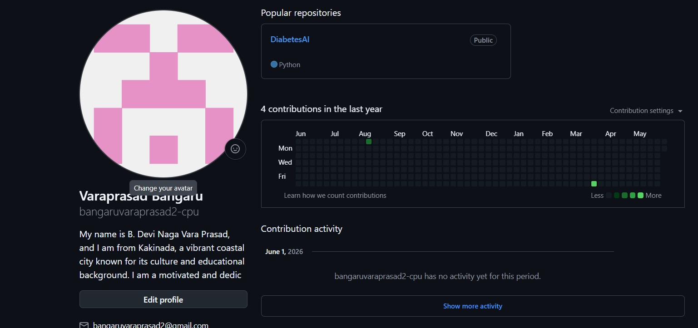

● Installed tools VISUAL STUDIO CODE (Screenshots)

